LIBRARY WITH TIERED MEMBERSHIPS AND RESERVATION

ENTITIES AND ATTRIBUTES

1. **Member** 
   * **Member_ID** *(PK)*
   * Name
   * Type_ID *(FK)*
   * Email
   * Join_Date
2. **Membership** 
   * **TYPE_ID** *(PK)*
   * Membership_type
   * Reservation_Duration
   * Max_borrow_limit
   * Fine
3. **Books** 
   * **Book_ID** *(PK)*
   * Title
   * Author
   * Status
4. **Borrows** 
   * **Borrow_ID** *(PK)*
   * Member_ID *(FK → Member.Member_ID)*
   * Book_ID *(FK → Books.Book_ID)*
   * Fine
   * Borrow_date
   * Due_date
   * Return_date
5. **Reservation** 
   * **Reservation_ID** *(PK)*
   * Member_ID *(FK → Member.Member_ID)*
   * Book_ID *(FK → Books.Book_ID)*
   * Date
6. **Reading_History** 
   * **History_ID** *(PK)*
   * Member_ID *(FK → Member.Member_ID)*
   * Book_ID *(FK → Books.Book_ID)*
   * Read_Date
7. **Recommendation** 
   * **Recommendation_ID**
   * Member_ID *(FK → Member.Member_ID)*
   * Book_ID *(FK → Books.Book_ID)*
   * Reason

**RELATION:**

* + One member can have one membership.
  + A member can borrow multiple books.
  + A book can be reserved or borrowed.
  + Borrowing includes tracking dates and fines.

# ERD_DIAGRAM CROW FEET

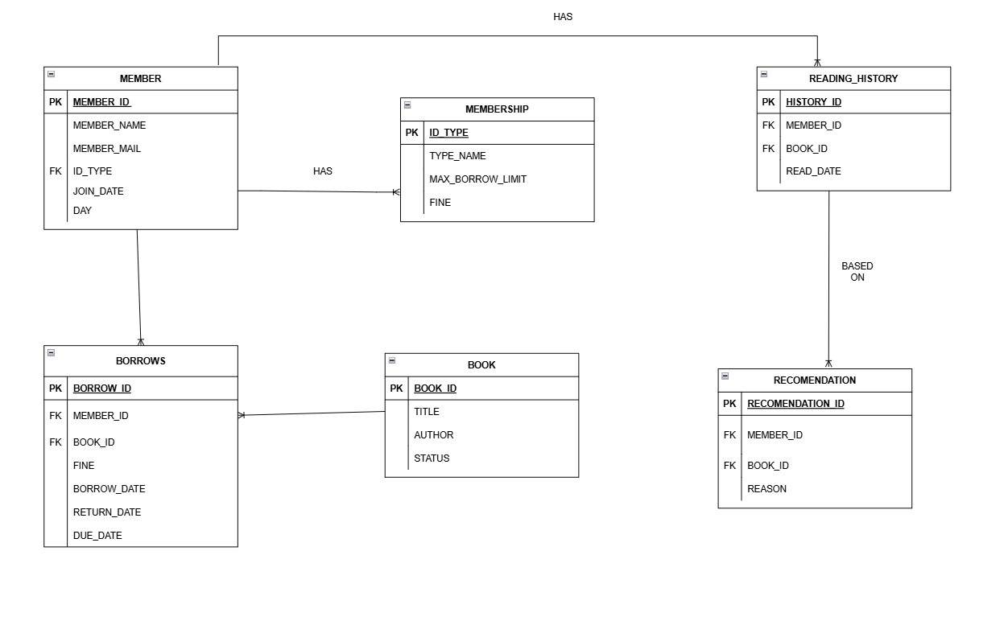

ERD_DIAGRAM CHEN MODEL

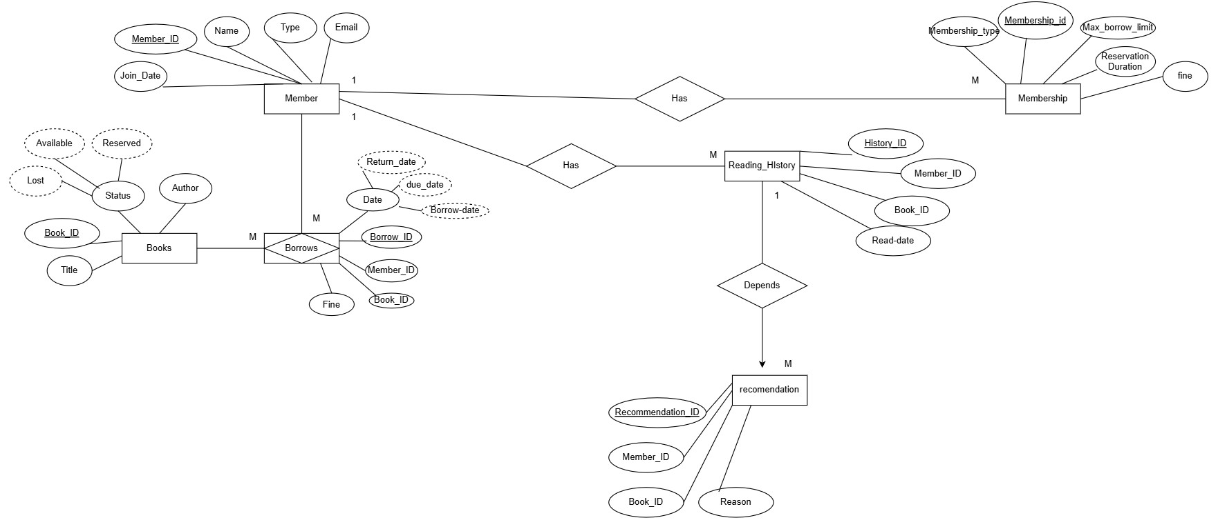

DATABASE TABLES AND QUERIES IN MYSQL:

IMPORTANT COMMANDS:

**SHOW DATABASES;**

**USE LIBRARY_MEMBERSHIP;**

**SHOW TABLES;**

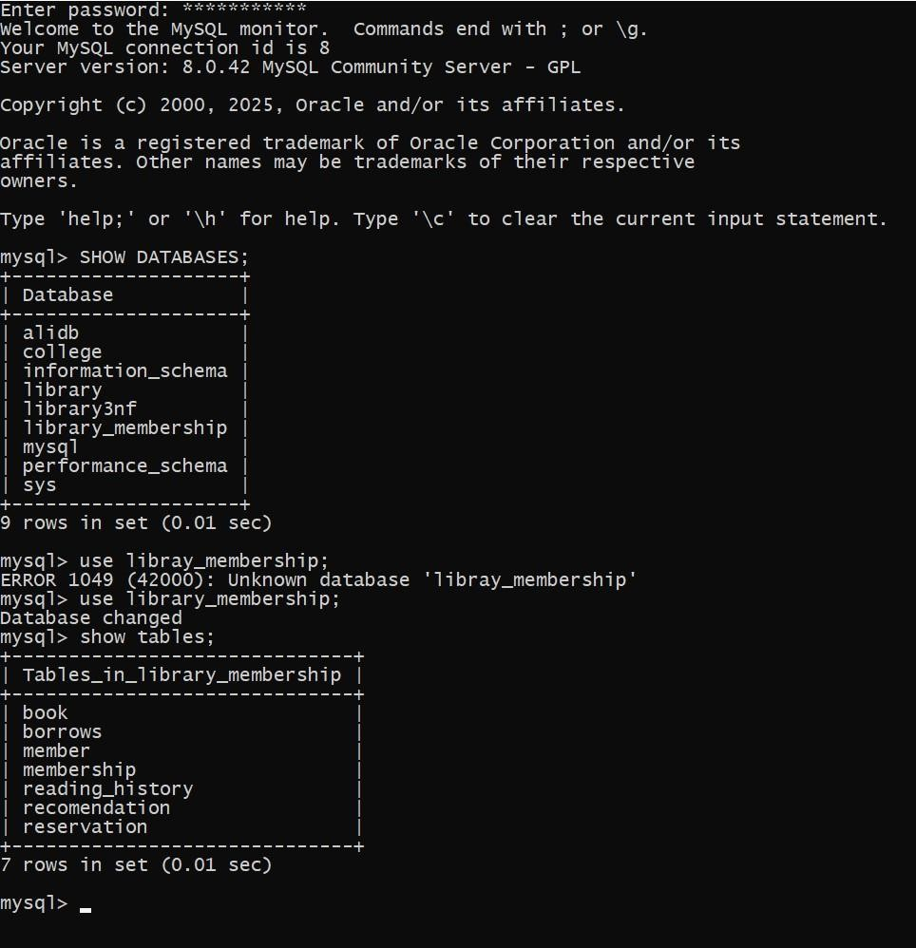

**DESC BOOK;**

**SELECT*FROM BOOK;**

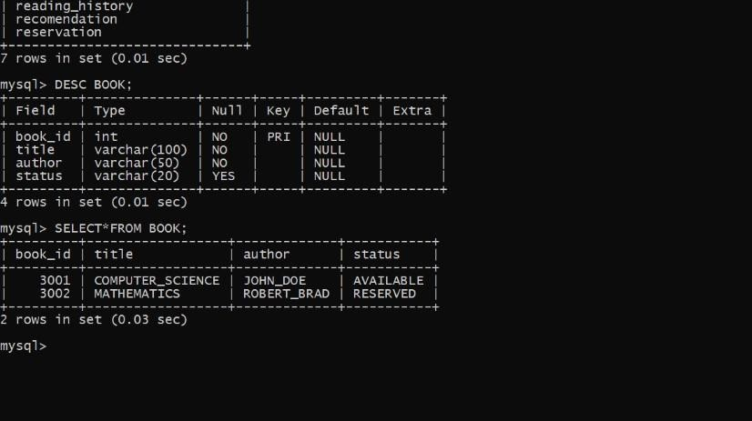

**DESC BORROWS;**

**SELECT*FROM BORROWS;**

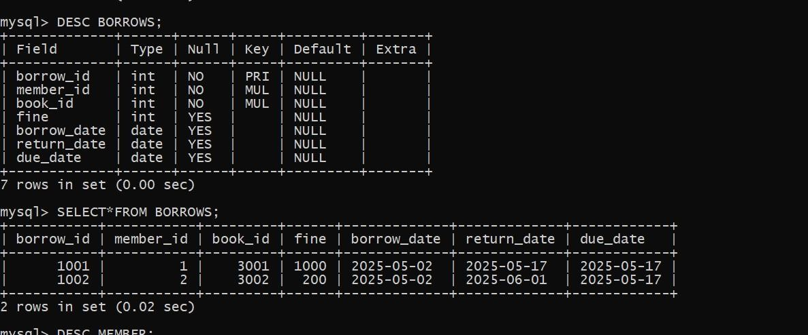

**DESC MEMBER;**

**SELECT*FROM MEMBER;**

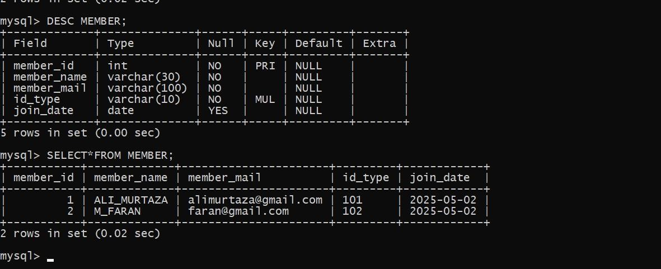

**DESC MEMBERSHIP;**

**SELECT*FROM MEMBERSHIP;**

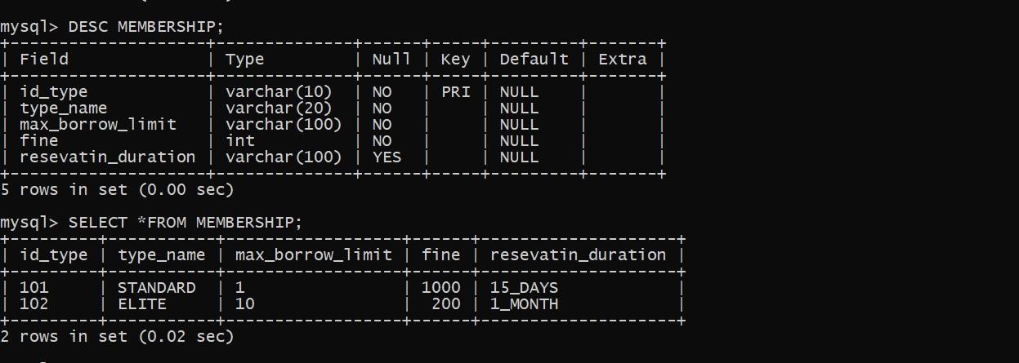

**DESC READING_HISTORY;**

**SELECT*FROM READING_HISTORY;**

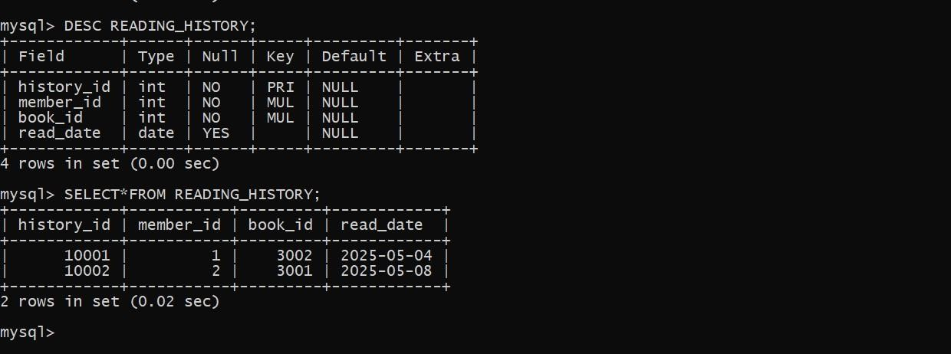

**DESC RECOMENDATION;**

**SELECT *FROM RECOMENDATION;**

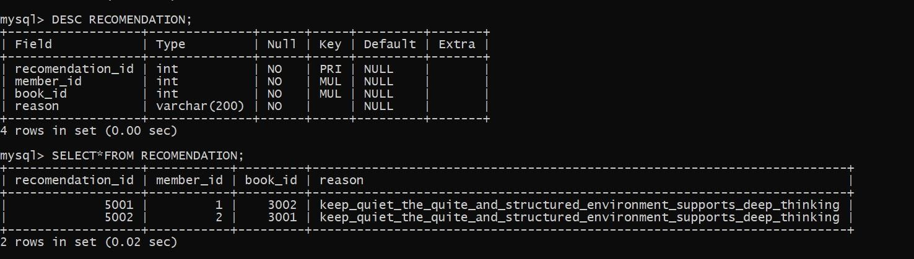

**DESC RESERVATION;**

**SELECT*FROM RESERVATION;**

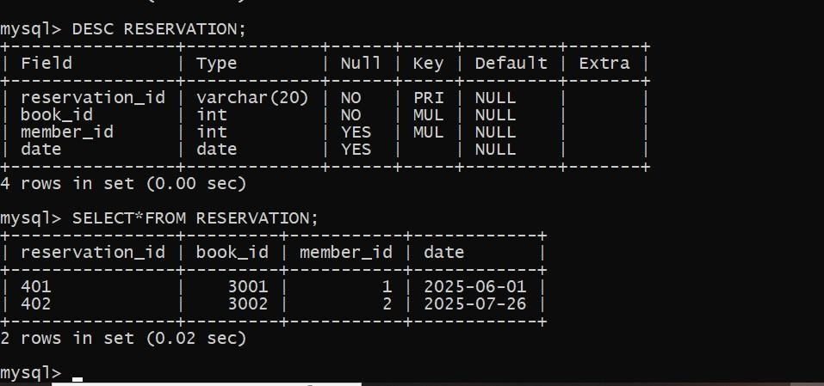

**QUERIES:**

**Fix incorrect column:**

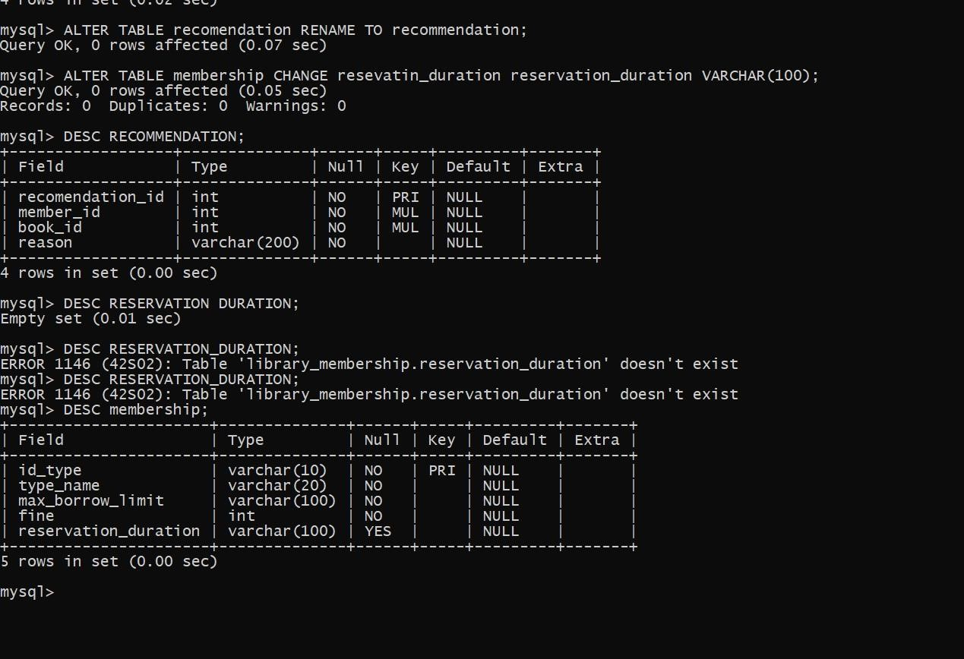

**Data cleaning:**

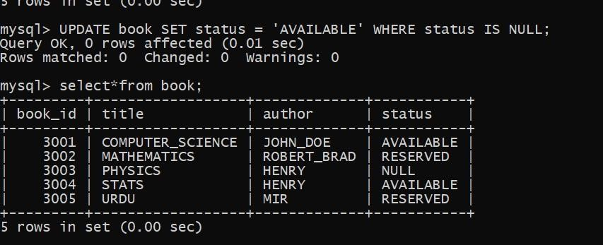

**Where clause:**

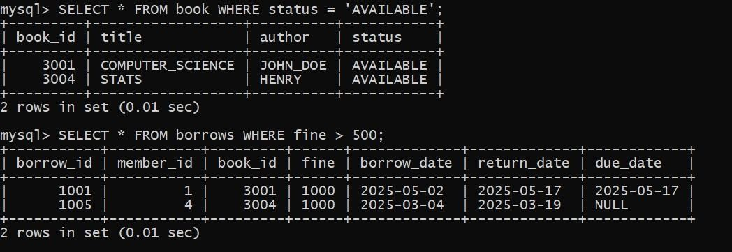

**A**



**s**



**Q**



**uerie:**

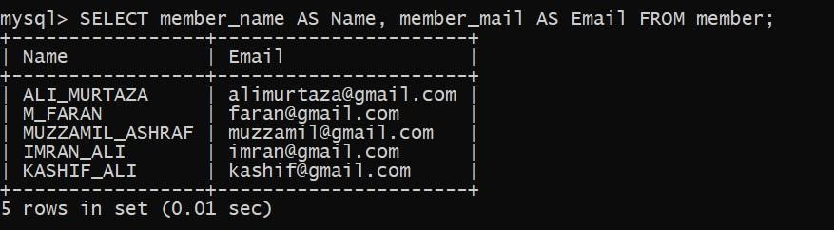

**Distinct:**

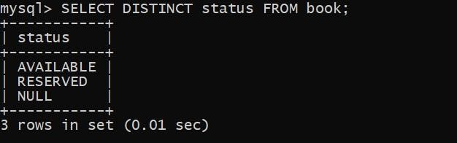

**Order by:**

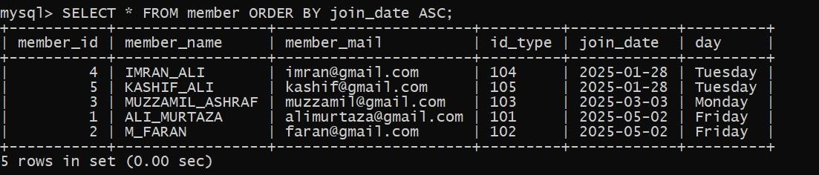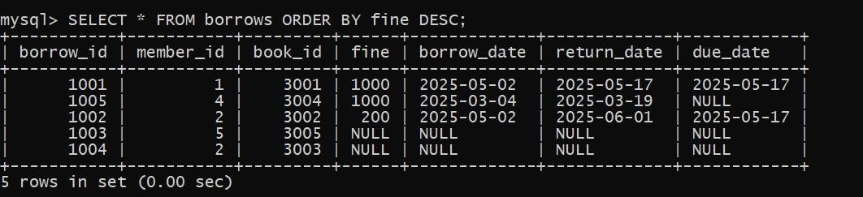

**Arithmetic operations:**

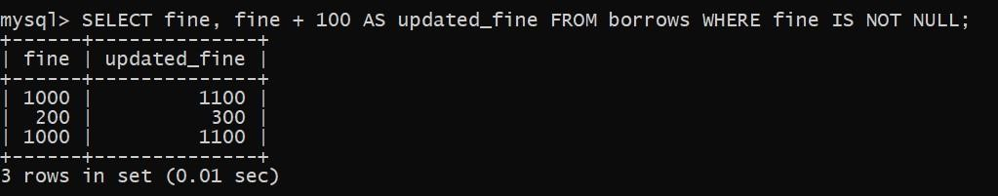

**Aggregate functions:**

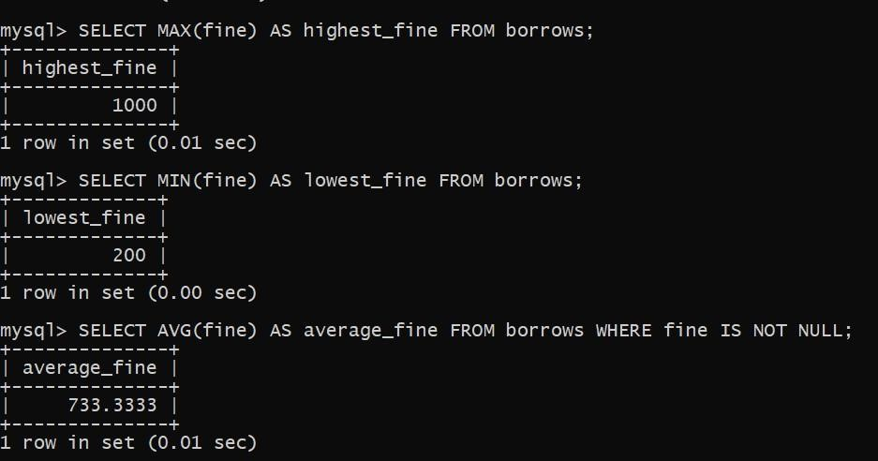

**Using Functions with Aliases and ORDER**

**BY:**

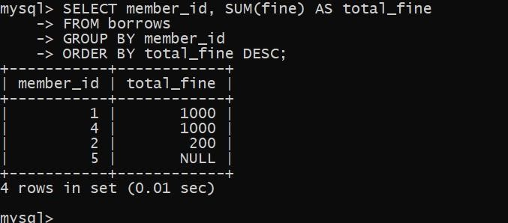

Joins:

Inner join:

Show Member Name, Book id, Date, Member_id:



I



nner



join:

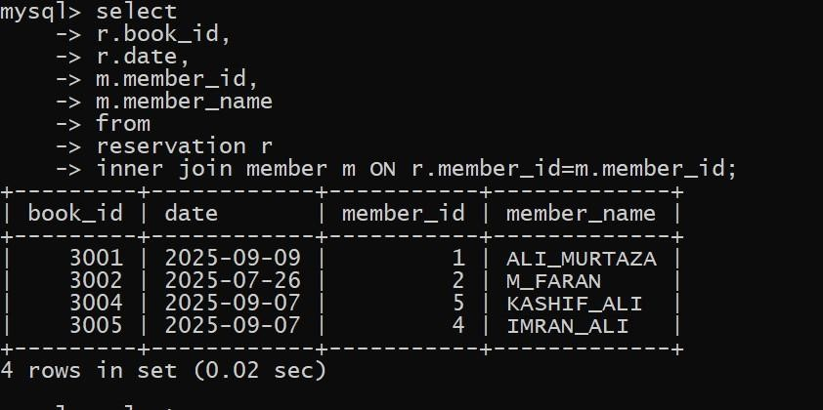

Show Member Name, Book id, Date, Member_id, with WHERE Clause.



I



nner



joi



n:

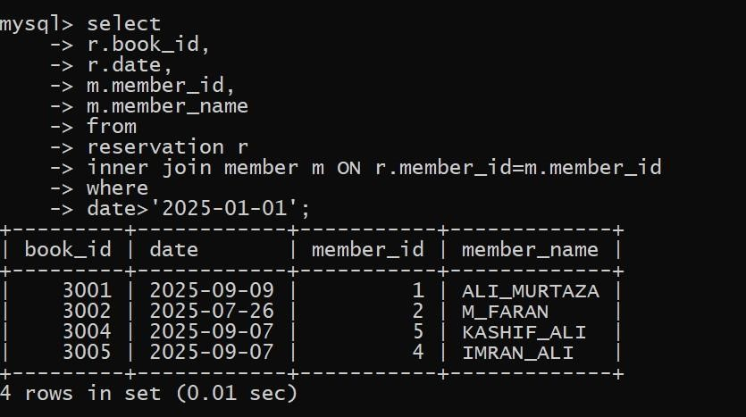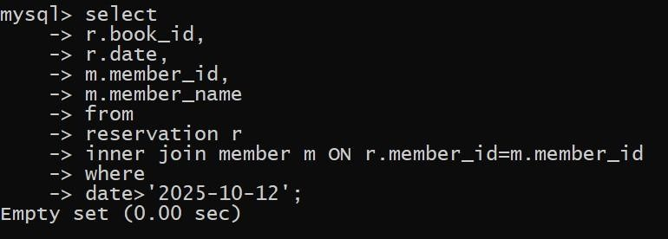

Member details with book title and fine from member, book, borrows.

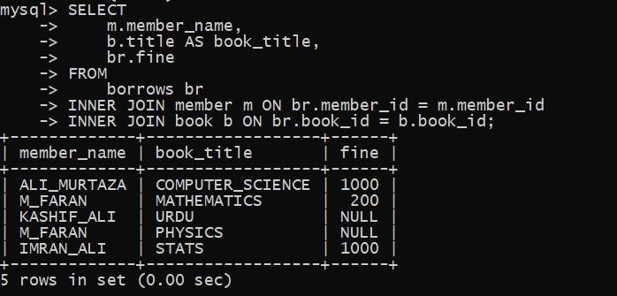

Group by and having with Joins:

Members who borrowed more than 1 book:

Members who’s total fine is >0:

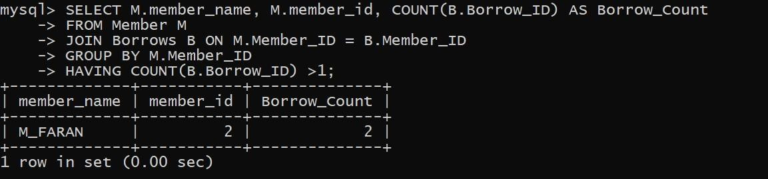

Members who borrowed more than 3 books:

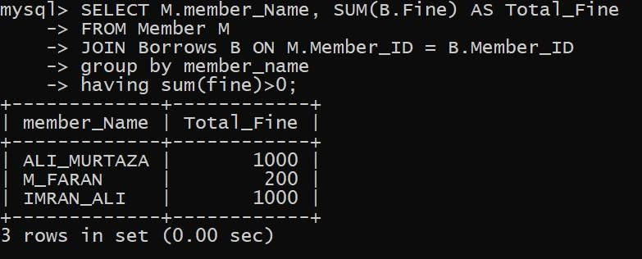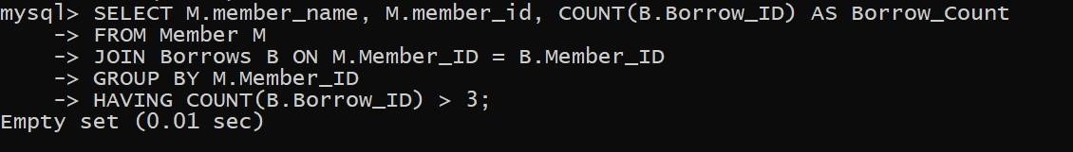

**Denormalization:**

1. Combine Tables (Joining Tables**)**

Avoid runtime JOINs by embedding related table info directly into borrows.

current borrows table already includes:

* book_title (from book)
* membership_type (from membership)
* Member_name (from member)

## 2. Precompute Derived Data (Storing Aggregates)

**Example Additions**:  
You could add a column like:

sql

CopyEdit

ALTER TABLE borrows ADD COLUMN borrow_duration INT;

Then calculate borrow_duration as:

sql

CopyEdit

UPDATE borrows

SET borrow_duration = DATEDIFF(return_date, borrow_date)

WHERE return_date IS NOT NULL AND borrow_date IS NOT NULL;

**Purpose**: Speeds up reports like average borrow duration per member.

✅ **3. Add Redundant Data (Copy from Parent Tables)**

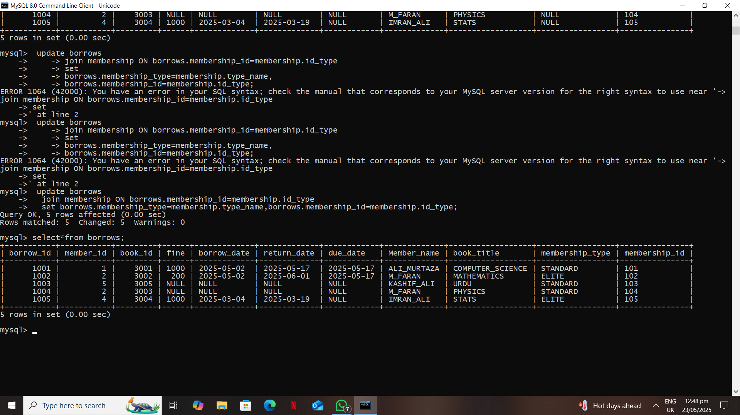

**4. Use Data Replication (Across Systems or Tables):**

This is generally handled **outside MySQL** (e.g., cache or reporting DB), but for **in-table replication**, you can do:

* Create a summary or reporting table (e.g., borrows_summary) with key redundant info:

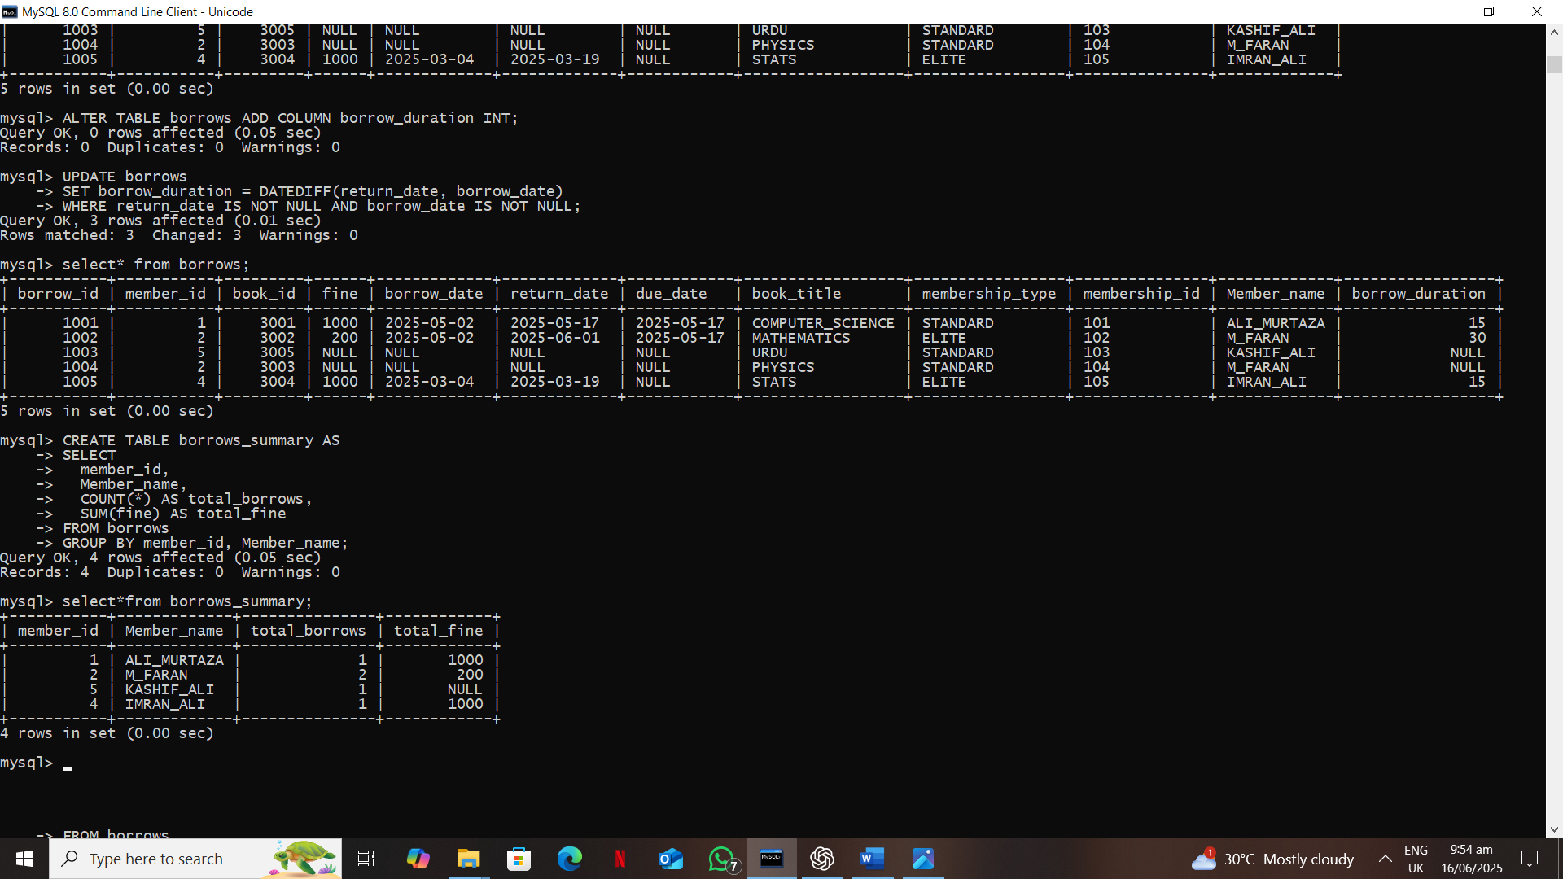

**5. Introduce Summary Tables (Materialized Views):**

Create summary tables for faster reporting: